TANZANIAN YOUTHS GRADUATE WITH FLYING COLOURS
On June 12, 2023, H.E. Alex Gabriel Kallua, Ambassador of the United Republic of Tanzania in Israel attended the first graduation of 99 youths from Tanzania who were doing modern agriculture internship at The Arava International Center for Agriculture Training - AICAT.
This is the first to graduate from AICAT since Tanzania joined the center in 2022. In his speech, H.E. Ambassador Kallua congratulated all graduates for completing their training successfully and urged them to be catalyst for change when they return to their respective countries by putting into practice what they learned in Israel. H.E the Ambassador had the opportunity to hand over certificates to all the graduates from Tanzania.
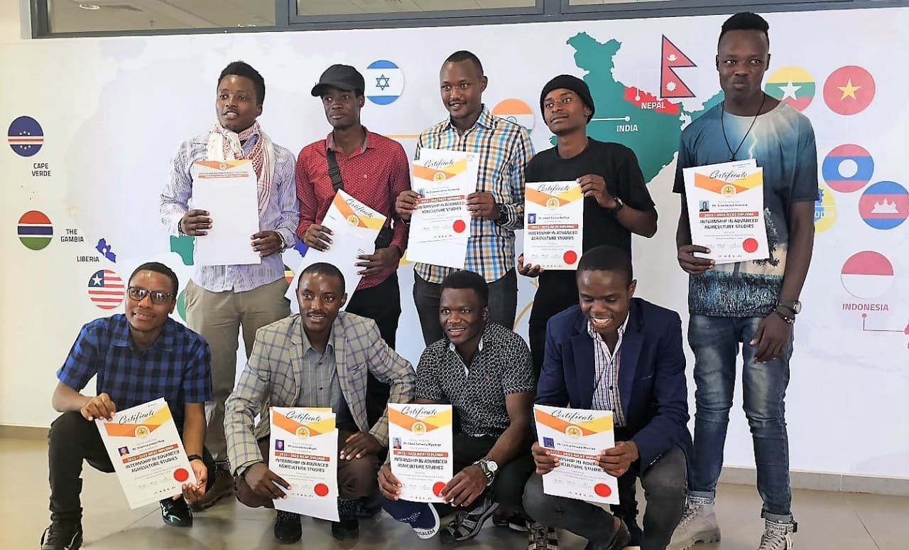
Tanzania youths’ academic year 2022/2023 posed with their certificates during AICAT graduation ceremony.
During the academic year 2022/2023, AICAT in corroboration with The Dean Family Fellowship introduce project competition to write and present a project proposal that the students concerned will do and bring positive changes to themselves and the community around them once they return home. One project proposal from Tanzanian youths won the competition and was awarded 6,000.00 US Dollars. In addition, 5 youths from Tanzania received the best students award.
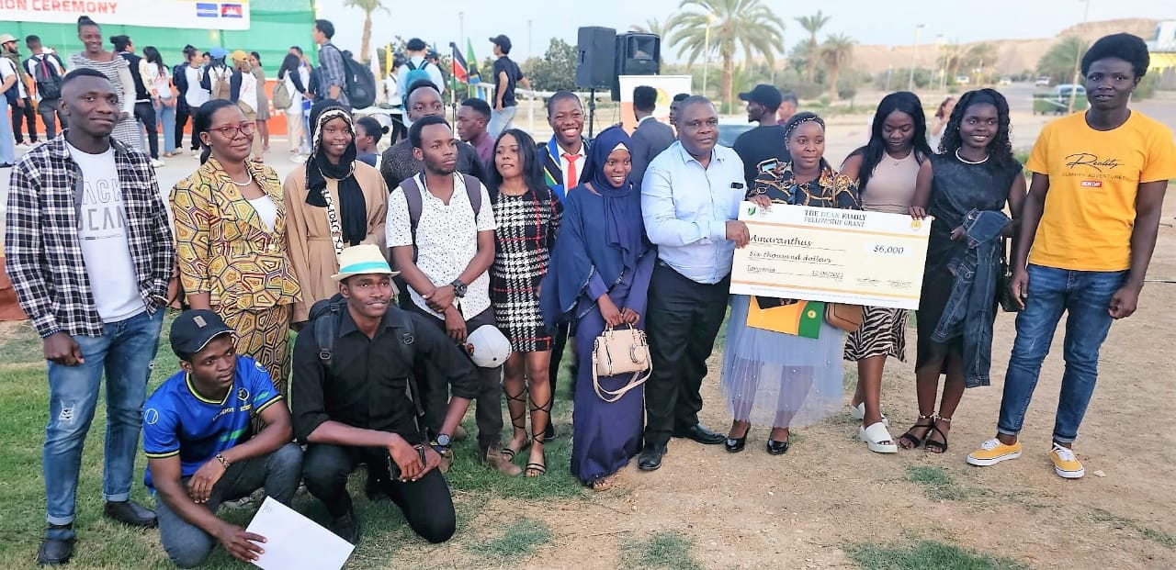
H.E. Alex Gabriel Kallua, Ambassador of the United Republic of Tanzania in Israel together with prize Winners of project proposal

H.E. Alex Gabriel Kallua, Ambassador of the United Republic of Tanzania in Israel together with 5 Tanzania best students
Due to discipline and his exceptional leadership skills, one student who was the leader of the Tanzanian group, has been given an offer to continue training for the next academic year.

The youths were deeply moved by their ambassador’s presence which gave them motivation, energy, and devotion to face the future.
For the academic year 2023/2024, Tanzania has been given 260 slots where 150 youths will be sent to Agrostudies and 110 will be sent to AICAT. These trainings are important for bringing about an agricultural revolution in the country.

